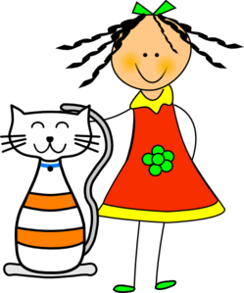
Nombre: Período: Fecha: 5A vocab


Una Fiesta de Cumpleaños
Español 1

TO talk about family members: TO talk about people:

grandparents person
grandfather
grandmother To name animals:
husband, wife cat
brothers; brother(s)and sister(s) dog
brother guinea pig: el conejillo de indias
sister rabbit: el conejo
stepbrother gerbil: el gerbo
stepsister hamster: el hamster, los hámsters
children; sons ferret: el hurón, los hurones
son parrot: el loro
daughter fish: el pez, los peces
parents snake: la serpiente
father turtle: la tortuga
mother
stepfather To Discuss what someone likes:
stepmother He/She likes
cousins He /she loves
(male) cousin To describe activities at parties
(female) cousin to open
Uncles; aunt(s) and uncle(s) to celebrate
Uncle to decorate
Aunt decorations
To discuss and compare ages: to videotape
How old is/are_________? video
He/She is/They are______(years old) to prepare
Older to break
Younger to take photos

lamp
photo
camera
To discuss celebrations: Possessive adjectives:
Birthday
Happy birthday!
candy
Flower
Balloon
Light
Cut-paper decorations
Cake Práctica: Traduce al español después de leer la
Gramática de arriba y vocabulario.
Piñata
- My mother is funny. _____________________________________
Gift, present
Other useful words: 2. The grandmother of my father is my: _____________________
Who, that __________________________________________________________
Only 3. The balloons are next to the piñata: _____________________
Extra vocab: pg 472 __________________________________________________________
Great-grandfather: bisabuelo 4. Our parents are intelligent and daring. __________________
Great-grandmother: bisabuela _________________________________________________________

Granddaughter: nieta
Grandson: nieto
Niece: sobrina
Nephew: sobrina

Gramática— “HIGH” TOP (go-go and stem-changer)
Tener: To have

